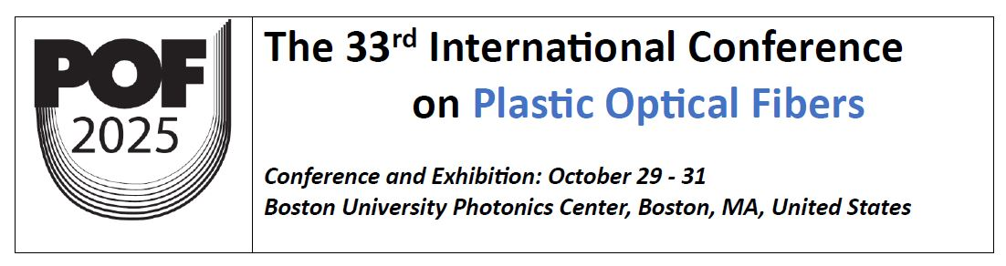

POF 2025 Registration Form

The registration fee includes: admission to the conference & exhibits, all coffee breaks & lunches, 1 ticket to the official conference dinner (if any), and 1 copy of the conference proceedings in PDF.
 | Early  (before September 20) | Regular  (after September 20)
General | US$700 | US$800
Student | US$350 | US$400

To qualify for the Student Registration rate, you must be a full-time student at an accredited university. Please submit a copy of valid ID (student card or official letter) to the POF2025 Secretariat by e-mail at pof@igigroup.com within one week of registration.

Registrant Information

First Name
Last Name
Title
University/Company
Address
City
State/Province
Zip / Postal code
Country
Telephone
Email
Total Amount | $

Instructions:

Please fill out the registration form and email it to POF 2025 Secretariat at: pof@igigroup.com.
You will receive details on how to make payment. Thank you.

