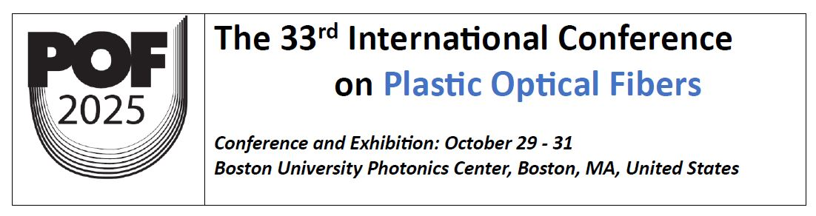
POF 2025 Sponsorships and Exhibits
A number of different sponsorship and exhibit options are being made available to POF companies and universities to provide them with promotion opportunities before and during the event. The opportunities include the following:
Corporate Sponsorship |  | Price | Conference Registration  Included | Table | Web Link | Logo on Document
 | Platinum | $5000 | 3 | 2 | Y | Y
 | Gold | $3000 | 2 | 1 | Y | Y
 | Silver | $2000 | 1 | 1 | Y | Y
 | Bronze | $1500 | 1 | 0 | Y | Y

Stand-alone  Exhibit Space |  | Price | Conference Registration  Included | Benefits
 | 4'x6' Table | $1500 | 1 | Table, drape, chairs, & company sign
 | Literature Bin | $250 | 0 | Bin near registration desk

Meals & Breaks Sponsorships |  | Price | Available (Total) | Benefits
 | Breakfast Sponsorship | $2000 each | 3 | Company Signs
 | Lunch Sponsorship | $3000 each | 3 | Company Signs
 | Coffee Breaks | $1500 each | 6 | Company Signs
 | Conference Dinner | $7000 | 1 | Company Signs

Documentation & Merchandise Sponsorships |  | Price | Benefits
 | Proceedings | $2000 | Logo on proceedings
 | Tote Bags / Pens | $2000 | Logo on one side
 | Name Badges | $1000 | Logo on Badge

Exhibit Floor Plan (East End Lounge)

The conference will be held in the Colloquium Room (906); exhibits are in East End Lounge

Please indicate your 1st and 2nd choices (Table numbers) on the application form. Tables are assigned on a first-come-first-served basis.

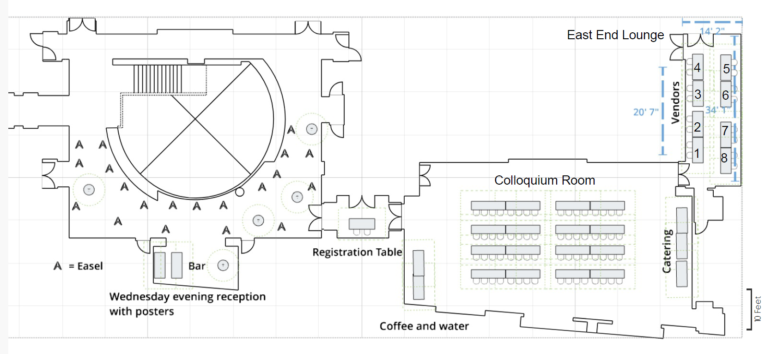
Sponsor and Exhibitor Contact Information

First Name
Last Name
University/Company
Address
City
State/Province
Zip / Postal code
Country
Telephone
Email
Website
Sponsorship | Platinum, Gold, Silver or Bronze, etc. (Check off your choice)
Exhibiting Tables | How Many Tables:
 | 1st Choice: Table No.
 | 2nd Choice: Table No.
Total Amount | $

Instructions:
Please mark your sponsorship or exhibit selections and fill out the contact information. Return the completed form to POF 2025 Secretariat via email: pof@igigroup.com
You will receive details on how to make payment. Thank you.

